**A PROJECT REPORT**

**ON**

**DEVELOPMENT OF SENSOR ARRAY FOR DETECTION OF TOXIC GASES IN ENCLOSED SPACE**

SUBMITTED TO THE SAVITRIBAI PHULE PUNE UNIVERSITY, PUNE

IN THE PARTIAL FULFILLMENT FOR THE AWARD OF THE DEGREE

**OF**

**BACHELOR OF ENGINEERING**

**IN**

**ELECTRONICS AND TELECOMMUNICATION**

**BY**

## Aditya Jadhav Exam No. B190363128

**Saurabh Hodlurkar Exam No. B190363124**

**Tejas Jadhav Exam No. B190363134**

**UNDER THE GUIDANCE OF**

**Mrs. S.R. PATIL**



**DEPARTMENT OF ELECTRONICS AND TELECOMMUNICATION ENGG**.

**STES’S**

**SMT. KASHIBAI NAVALE COLLEGE OF ENGINEERING**

**VADGAON BK., OFF.SINHGAD ROAD**

**PUNE 411041**

**2023– 2024**



**CERTIFICATE**

This is to certify that the Project report entitled

“**DEVELOPMENT OF SENSOR ARRAY FOR DETECTION OF TOXIC GASES IN ENCLOSED SPACE**”

**Submitted by**

## Aditya Jadhav Exam No. B190363128

Saurabh Hodlurkar Exam No. B190363124

Tejas Jadhav Exam No. B190363134

is a bonafide work carried out by them under the supervision of Mrs. S.R. Patil and it is approved for the partial fulfillment of the requirement of Savitribai Phule Pune University for the award of the Degree of Bachelor of Engineering (Electronics and Telecommunication Engineering).

This project report has not been earlier submitted to any other Institute or University for the award of any degree**.**

|  |
| --- |
| Mrs. S.R. Patil |
| **Guide**  **Department of E & TC**  **SKNCOE, Pune** |

|  |  |  |
| --- | --- | --- |
| Mr. P. S. Kokare /Ms. M.M.Sonkhaskar | Dr. S.K. Jagtap | Dr. A.V. Deshpande |
| **Project Coordinators** | **Head (E&TC)** | **Principal** |
| **SKNCOE, Pune** | **SKNCOE, Pune** | **SKNCOE, Pune** |

Place: Pune

Date : 23/05/2024

**CERTIFICATE FROM INDUSTRY**

**ACKNOWLEDGEMENT**

We express our sincere gratitude to all those who have contributed to our project titled "Development Of Sensor Array for Detection of Toxic Gases in Enclosed Space ".

We would like to thank our esteemed institution, Smt. Kashibai Navale College of Engineering, for providing us with the necessary resources, infrastructure, and support to carry out this project. We are also grateful to our project guide **Mrs. S.R. Patil** for her guidance, mentorship, and valuable inputs throughout the project duration.

We would like to express my deepest gratitude to **Dr. Suwarna Datar** (HoD Dept. of applied physics, DIAT, Pune) for her invaluable guidance and support throughout this project. Her expertise, insightful feedback, and unwavering encouragement were instrumental in shaping the direction and success of this work. We are immensely grateful for her mentorship and the time she dedicated to helping me achieve our goals.

We extend our heartfelt thanks to Head of the Department **Dr. S.K. Jagtap** for her valuable inputs, encouragement, and support during the course of our project. We are also grateful to the technical staff for their assistance in setting up the experimental setup and providing technical support whenever needed.

We would like to thank our Principal **Dr**. **A.V.** **Deshpande** for his valuable inputs, encouragement and support during the course of our project.

Last but not least, we express our gratitude to all the authors of the references and resources we have referred to during our project. Their work has been invaluable in shaping our understanding of the project domain and guiding us in the right direction.

We acknowledge the contributions of all those who have been involved in this project directly or indirectly and express our heartfelt appreciation for their support.

**ABSTRACT**

In an era where rapid industrialization and urbanization continue to shape our environment, ensuring the safety and well-being of individuals in enclosed spaces is of paramount importance. One of the key challenges in this endeavor is the detection of toxic gases and volatile organic compounds (VOCs) that can pose severe health risks if left undetected. So, the primary motive of this model is to design and implement a sensor array system comprising five specialized sensors which are capable detecting a wide range of toxic gases. Employing Raspberry Pi and Arduino platforms for simultaneous data acquisition, the project sought to improve accuracy and real-time monitoring. The system's versatility extended to the detection of volatile organic compounds, with applications spanning industrial, residential, and laboratory settings. Calibration procedures were rigorously undertaken to enhance measurement reliability. The key results of this endeavor encompassed the successful development and calibration of the sensor array, culminating in a comprehensive solution for toxic gas detection in enclosed spaces. Ultimately, this project contributes significantly to safety and environmental well-being.

### CONTENTS

CERTIFICATE i

CERTIFICATE FROM INDUSTRY  iiACKNOWLEDGEMENT iii

ABSTRACT iv

INDEX v

LIST OF FIGURES vii

LIST OF TABLES viii

**INDEX**

**CHAPTER TITLE PAGE NO.**

**1.** **INTRODUCTION** *1- 5*

* 1. BACKGROUND 2
  2. RELEVANCE 3
  3. PROJECT UNDERTAKEN 3
  4. SUMMARY 5

**2.** **LITERATURE SURVEY** *6-9*

2.1 INTRODUCTION 7

* 1. SUMMARY 9

**3. DESIGN AND DRAWING** *10-13*

3.1 INTRODUCTION 11

3.2BLOCK DIAGRAM 12

3.3 PCB DESGIN13

3.4 SUMMARY 13

1. **IMPLEMENTATION** *14-23*

4.1 INTRODUCTION 15

4.2 IMPLEMENTATION 16

4.3 SOFTWARE REQUIREMENTS 17

4.4 HARDWARE REQUIREMENTS 17

4.5 COMPINENTS USED 18

* 1. **5. EXPERIMENTATION** *24-28*
     + - 1. 5.1 INTRODUCTION 25

5.2 TESTING OF SENSORS 26

5.3 FINAL MODEL 27

**6.** **RESULTS AND DISCUSSION** *29-33*

6.1 INTRODUCTION 30

6.2 RESULTS 31

**7.** **CONCLUSIONS** *34-35*

**8. REFERENCES** *36-38*

**LIST OF FIGURES**

|  |  |  |
| --- | --- | --- |
| **FIGURE NO.** | **TITLE** | **PAGE NO.** |
| 3.2 | Block diagram of Sensor Array System | 12 |
| 3.3 | PCB design of the proposed model | 13 |
| 4.5.1 | Renesas ZMOD4510AI1R sensor | 18 |
| 4.5.2 | Pin Assignment of ZMOD4510AI1R | 18 |
| 4.5.3 | SCD40-D-R1 Sensor | 19 |
| 4.5.4 | Pin assignment of SCD40-D-R1 | 19 |
| 4.5.5 | MQ136 Sensor | 20 |
| 4.5.6 | MS1100 Sensor | 21 |
| 4.5.7 | CO Sensor Module ZE07-CO | 22 |
| 4.5.8 | Raspberry Pi | 23 |
| 4.5.9 | Arduino Board | 24 |
| 5.2 | Testing of Sensors | 26 |
| 5.3.1 | Intial PCB Desgin | 27 |
| 5.3.2 | Proposed Model | 27 |
| 5.3.3 | Front Side of the model | 28 |
| 5.3.4 | Back Side of the model | 28 |
| 6.2.1 | Testing of MS1100 Sensor with Benzene | 31 |
| 6.2.2 | Testing of MS1100 Sensor with Toluene | 31 |
| 6.2.3 | Testing of MS1100 Sensor with Formaldehyde | 32 |
| 6.2.4 | Testing of MQ136 Sensor with Benzene | 32 |
| 6.2.5 | Testing of MQ136 Sensor with Formaldehyde | 33 |
| 6.2.6 | Testing of MQ136 Sensor with Toluene | 33 |

**LIST OF TABLES**

|  |  |  |
| --- | --- | --- |
| **TABLE NO.** | **TITLE** | **PAGE NO.** |
| 1 | Description of ZMOD4510AI1R | 18 |
| 2 | Description of SCD40-D-R1 | 19 |
| 3 | Description of MQ136 Sensor | 20 |
| 4 | Description of MS-1100 Sensor | 21 |
| 5 | Description of CO Sensor Module ZE07-CO | 22 |

**CHAPTER 1 INTRODUCTION**

1. **INTRODUCTION**
   1. **BACKGROUND**

In today's rapidly evolving world, the need for advanced technologies to ensure environmental safety and human well-being is more significant than ever before. The precise detection of toxic gases and volatile organic compounds (VOCs) in enclosed areas is one of the most important components of protecting lives and protecting the environment. These gases, often colourless and odourless, are extremely dangerous to human health. By developing a sensor array system, this proposed model aims to address this important issue.

Traditional gas detection techniques often rely on single sensors, each of which is designed to detect a particular gas. However, these single-sensor systems do have limits, though, as they might not offer a thorough evaluation of the air quality inside a closed environment. The proposed model seeks to overcome these limitations by developing a sensor array system that can simultaneously monitor multiple toxic gases and VOCs.

This project recognizes these limitations and endeavors to address the complex nature of indoor air quality by employing an innovative sensor array system. The sensor array is designed to simultaneously monitor a range of toxic gases and VOCs, thus providing a more comprehensive assessment of the indoor environment. Such an integrated approach enables not only the detection of multiple contaminants but also the quantification of their concentrations, which is invaluable for assessing health risks and taking timely corrective actions.

The primary objective of this model is to use a sensor array system to find volatile organic chemicals that are present in enclosed spaces. This application covers a wide range of situations where the presence of dangerous gases could endanger people's health and safety, such as industrial facilities, laboratories, residential areas, and more.

* 1. **RELEVANCE**

The relevance of this proposed model is underscored by the pressing need to safeguard the health and well-being of individuals living and working in enclosed environments. As urban populations grow and industrial processes expand, the risk of exposure to toxic gases and VOCs in indoor settings increases. Thus, this project holds several layers of relevance.

First, it addresses a critical global issue by striving to enhance indoor air quality and safety. Toxic gases and VOCs are insidious health hazards that affect millions of people daily, with potential life-altering consequences. By developing an advanced sensor array system, we aim to provide a means of early detection, reducing the health risks associated with exposure to these harmful substances.

Second, the project aligns with the increasing adoption of sensor technology and the Internet of Things (IoT) in the field of environmental monitoring. The fusion of multiple sensors within a single array, coupled with advanced data acquisition and analysis, reflects a forward-thinking approach that is in line with the broader trend of integrating technology into everyday life.

Third, it carries the potential to revolutionize the way we monitor indoor air quality. Traditional single-sensor systems often fall short in providing a comprehensive assessment of indoor environments. The proposed sensor array not only enables the simultaneous detection of multiple contaminants but also offers the capacity to provide quantitative concentration data, a feature critical for making informed decisions regarding the safety of enclosed spaces.

* 1. **PROJECT UNDERTAKEN**

The proposed model is a multifaceted initiative aimed at designing, developing, and implementing an innovative sensor array system. This system's primary objective is to comprehensively monitor and detect toxic gases and volatile organic compounds (VOCs) in enclosed spaces. This undertaking is structured around the following key components and methodologies:

1. Sensor Array System Development

The heart of this project lies in the development of a sophisticated sensor array system. We have selected and integrate five distinct sensors (ZMOD4510AI1R, SCD40-D-R1, MQ136, MS-1100, CO Sensor Module ZE07-CO), each chosen for its capability to detect specific gases and VOCs commonly found in enclosed spaces. These sensors will collectively provide a comprehensive solution for gas and VOC detection. The array system's PCB design and construction will involve careful consideration of sensor placement, power supply, and data communication to ensure seamless operation.

2. Data Acquisition with Raspberry Pi and Arduino

Raspberry Pi and Arduino, being versatile and widely used computational platforms, will be instrumental in acquiring data from the sensor array system. Raspberry Pi's computational capabilities will facilitate data processing, storage, and remote monitoring, while Arduino's ability to interface with the sensors will ensure real-time data collection. The integration of these platforms will enable efficient and synchronized data acquisition from all sensors, improving the system's reliability and effectiveness.

3. Detection of Volatile Organic Compounds (VOCs)

In addition to the detection of toxic gases, this project aims to enhance the sensor array's capabilities to identify VOCs. Given the diversity and potential harmfulness of VOCs, their detection is vital for comprehensive indoor air quality monitoring. Specialized sensors will be integrated into the array to enable the system to detect a range of VOCs, including acetaldehyde, benzene, and formaldehyde.

4. Sensor Calibration

The accuracy and reliability of the sensor array system are dependent on proper calibration. Calibration involves adjusting the sensors to provide precise readings for different concentrations of specific gases and VOCs. The project will include calibration procedures for acetaldehyde, nitrogen dioxide (NO), and carbon monoxide (CO) across a range of concentrations to ensure the system's capacity to provide accurate data.

5. Data Analysis and Visualization

Collected data will be analyzed to interpret trends, identify concentration levels, and assess the overall indoor air quality. The project will employ Machine learning algorithms, data visualization techniques to present this information in an understandable format, facilitating informed decision-making regarding indoor air quality management.

**1.4 SUMMARY**

The proposed model represents a comprehensive and innovative approach to addressing the critical issue of indoor air quality and safety. By achieving the outlined objectives and following the project undertaking, we aim to make substantial contributions to enhancing the well-being and health of individuals in enclosed environments. Through the synergy of advanced sensor technology, computational platforms, calibration techniques, and data analysis, this project is poised to provide a versatile solution for indoor air quality monitoring and detection of toxic gases and VOCs.

**CHAPTER 2**

**LITERATURE SURVEY**

1. **LITERATURE SURVEY**
   1. **INTRODUCTION**

**A. Holovatyy, V. Teslyuk, M. Lobur, S. Pobereyko and Y. Sokolovsky, "Development of Arduino-Based Embedded System for Detection of Toxic Gases in Air, 2018 IEEE”[1]**

This study presents the development of a dangerous gasses detecting system in the air environment. It tracks the amount of harmful vapors and gases in the air in real time. The system operates in the standard mode (monitoring mode) when there are no dangerous gases present or when their concentration is acceptable. The system enters alert mode when the maximum amount of harmful gasses allowed is surpassed. When in alarm mode, it activates the red LED, the buzzer, outputs an alarm message to the PC and LCD module via the serial interface, and uses a GSM module to send SMS messages to the mobile device.

**M. Jualayba, K. Regio, H. Quiozon And A. Destreza, "Hazardous Gas Detection and Notification System, 2018 IEEE” [2]**

Combustible hazardous gases, such as methane and propane, have the potential to explode in a small space. The research presented in this paper includes a method for identifying and alerting people to the presence of dangerous chemicals in a given region. The three sensors in the system—the methane, hydrogen, and liquefied petroleum gas (LPG) sensors—act as switches with various set-points. Each measured gas level is relayed to the Arduino, which acts as a controller and analyzes the amount of gas in the environment.

**“Detection of volatile organic compounds using a commercial gas sensor embedded in a mobile robot, by G. A. García-Rodriguez, Mexico, 2021” [3]**

This research highlights the possible effects of volatile organic compounds (VOCs) on agriculture, blood, and human health while introducing a novel unmanned mobile equipment for the detection of VOC leakage. The system consists of a receiver and an emitter. An 8-bit microcontroller houses two embedded systems in the emitter. Two systems are used to monitor the amounts of volatile organic compounds (VOCs). The first system uses proximity and line-following sensors to regulate and make decisions for the robot, while the second system uses commercial gas sensors to detect VOCs at a concentration of 10 to 1000 parts per million (ppm).

**“Very volatile organic compounds: an understudied class of indoor air pollutants by T. Salthammer” [4]**

Very volatile organic compounds (VVOCs), as categorized by the WHO, are an important subgroup of indoor pollutants and cover a wide spectrum of chemical substances. Some VVOCs are components of products commonly used indoors, some result from chemical reactions and some are reactive precursors of secondary products. Nevertheless, there is still no clear and internationally accepted definition of VVOCs. Current approaches are based on the boiling point, and the saturation vapor pressure or refer to analytical procedures.

**“Epping, R.; Koch, M. On-Site Detection of Volatile Organic Compounds (VOCs). Molecules 2023, 28, 1598” [5]**

There are numerous fields that are interested in volatile organic compounds, or VOCs. Food and fragrance analysis, atmospheric and environmental research, industrial uses, security, and life and medical sciences are a few of them. In the past, sample collection and off-site analysis were the primary methods used to characterize these chemicals, with gas chromatography coupled to mass spectrometry (GC-MS) serving as the gold standard. Although effective, this approach has a number of disadvantages, including being costly, time-consuming, and user-intensive.

**“A.K. Srivastava, Detection of volatile organic compounds (VOCs) using SnO2 gas-sensor array and artificial neural network” [6]**

This paper describes the design and development of an electronic nose system for the identification of some volatile organic compounds (VOCs) relevant to environmental monitoring, such as propane-2-ol, methanol, acetone, ethyl methyl ketone, hexane, benzene, and xylene. The system is based on an array of tin oxide gas sensors and artificial neural networks (ANNs). Response patterns are generated by a variety of SnO2-based thick-film gas sensors doped with Pd, Pt, and Au. Identification is performed using a backpropagation neural network. A novel approach to data transformation, which utilizes the mean and variance of each gas-sensor combination, has been used to enhance the neural network classifier's classification precision. By changing the array's size and contaminating the data, the impact of data transformation on a neural network's classification performance is investigated.7

**Galstyan, Vardan, D’Arco, Annalisa, Di Fabrizio, Marta, Poli, Nicola, Lupi, Stefano and Comini, Elisabetta. "Detection of volatile organic compounds: From chemical gas sensors to terahertz spectroscopy" [7]**

Air pollution is caused by the discharge of volatile organic compounds from several sources. Furthermore, a few of these organic compounds based on carbon are thought to be biomarkers in people's exhaled breath, meaning they can be used to identify a variety of ailments. As a result, the need to regulate both human health and air quality has increased, which has prompted the creation of monitoring systems built around highly effective gas detecting structures. The advancements in sensing technology for the identification of volatile organic molecules are highlighted in this review. Specifically, terahertz spectroscopy-based chemiresistive gas sensors and detecting systems are described. The development of research studies is examined, and the potential of both approaches is assessed in light of the difficulties that exist today.

**“Itoh, T.; Koyama, Y.; Shin, W.; Akamatsu, T.; Tsuruta, A.; Masuda, Y.; Uchiyama, K. Selective Detection of Target Volatile Organic Compounds in Contaminated Air Using Sensor Array with Machine Learning” [8]**

Aging Notes and Mold Smells in Simulated Automobile Interior Contaminant Gases. Sensors 2020” In the presence of interference volatile organic compounds (VOCs) from car interiors (n-decane and butyl acetate), we studied the selective detection of target VOCs, which are age-related body odors (namely, 2-nonenal, pelargonic acid, and diacetyl) and a fungal odor (namely, acetic acid). We utilized a sensor array consisting of eight semiconductive gas sensors, and we analyzed their signals using machine learning, principal component analysis (PCA), and linear discriminant analysis (LDA) as dimensionality-reduction techniques; we also used k-nearest-neighbor (kNN) classification to assess the precision of target-gas determination, and we selected suitable sensors from our sensor array using random forest and ReliefF feature selections. The sensor responses to each target gas with contaminant gases often produced PCA and LDA scores within the range of each target gas; as a result, discrimination between each target gas was

**2.2 SUMMARY**

These literature references provide insights into the design and implementation of the sensor array to detect toxic VOCs in an enclosed space. They discuss the principles of operation, hardware connections , testing results of such systems and provides valuable information.

**CHAPTER 3**

**DESGIN AND DRAWING**

1. **DESGIN AND DRAWING**

**3.1 INTRODUCTION**

In response to the escalating concerns surrounding toxic gases and volatile organic compounds (VOCs) in various environments, this proposed model presents a toxic gas detection system that integrates cutting-edge sensor technology with the computational capabilities of a Raspberry Pi. The system incorporates a carefully curated array of five specialized sensors, namely ZMOD4510AI1R, SCD40-D-R1, MQ136, MS-1100, and CO Sensor Module ZE07-CO. These sensors collectively offer a broad spectrum of detection capabilities, enabling the identification of diverse toxic gases and VOCs.

The central processing unit and control hub of this advanced system is the Raspberry Pi, which orchestrates the seamless integration and operation of the sensor array. In real-time, the Raspberry Pi collects precise numerical data indicative of gas concentrations, providing invaluable insights into the environmental conditions. This data is efficiently channeled into a dedicated storage system, facilitating historical record-keeping and in-depth analysis.

Beyond immediate monitoring and alerting capabilities in environments prone to toxic gases, the comprehensive nature of this system empowers long-term data insights. The integration of advanced sensors with the Raspberry Pi not only ensures real-time safety but also facilitates informed decision-making through historical data analysis. This novel approach contributes to enhancing safety measures and promoting environmental well-being in diverse settings.

The primary objective of this model is to use a sensor array system to find volatile organic chemicals that are present in enclosed spaces. This application covers a wide range of situations where the presence of dangerous gases could endanger people's health and safety, such as industrial facilities, laboratories, residential areas, and more.

**3.2 BLOCK DIAGRAM**

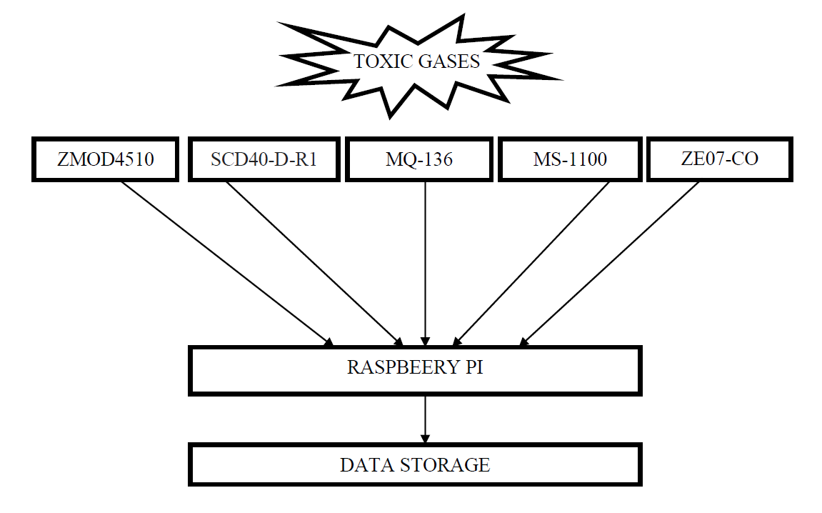

Figure 3.2: Block diagram of Sensor Array System.

The block diagram illustrates an advanced toxic gas detection system featuring a sensor array comprising five specialized sensors: ZMOD4510AI1R, SCD40-D-R1, MQ136, MS-1100, and CO Sensor Module ZE07-CO, all meticulously selected to detect a wide spectrum of toxic gases and volatile organic compounds (VOCs). These sensors are seamlessly integrated with a Raspberry Pi, serving as the central processing unit and control hub. The Raspberry Pi orchestrates the data acquisition process, constantly collecting real-time data from the sensor array, including precise numerical values indicative of gas concentration. This invaluable data is efficiently channelled into a dedicated data storage system, facilitating historical record-keeping and in-depth analysis. This comprehensive system not only enables immediate monitoring and alerting in toxic gas prone environments but also empowers long-term data insights for informed decision-making, enhancing safety and environmental well-being.

**3.3 PCB DESGIN**

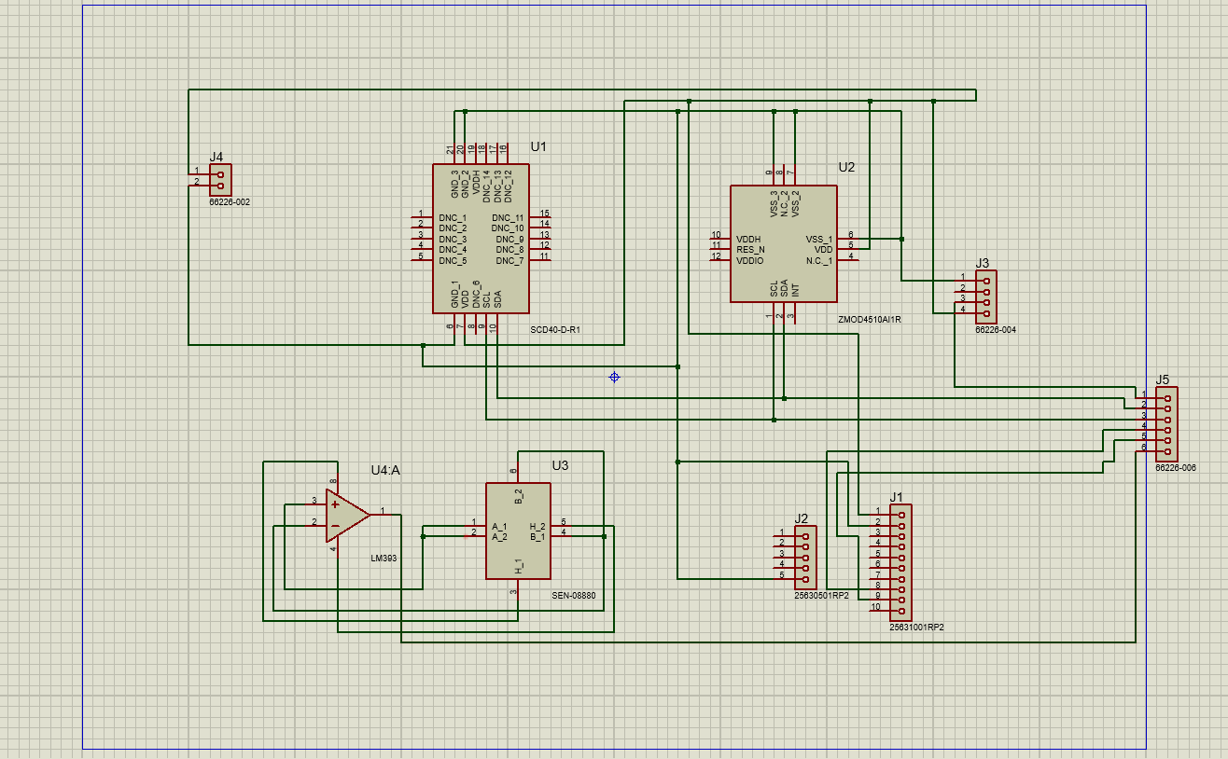

Figure 3.3: PCB design of the proposed model

**3.3 SUMMARY**

The presented block diagram illustrates an advanced toxic gas detection system that incorporates a sensor array with five specialized sensors—ZMOD4510AI1R, SCD40-D-R1, MQ136, MS-1100, and CO Sensor Module ZE07-CO. These sensors are meticulously chosen to detect a broad spectrum of toxic gases and volatile organic compounds (VOCs). Integrated seamlessly with a Raspberry Pi, which acts as the central processing unit and control hub, the system orchestrates the data acquisition process by collecting real-time data from the sensor array. The collected data, consisting of precise numerical values indicative of gas concentrations, is efficiently channeled into a dedicated data storage system, enabling historical record-keeping and in-depth analysis. This comprehensive system not only facilitates immediate monitoring and alerting in environments prone to toxic gases but also empowers long-term data insights for informed decision-making, thereby enhancing safety and environmental well-being

**CHAPTER 4**

**IMPLEMENTATION**

1. **IMPLEMENTATION**

**4.1 INTRODUCTION**

The escalating concerns surrounding the presence of toxic gases and volatile organic compounds (VOCs) in enclosed spaces have underscored the imperative for advanced detection systems to safeguard human health and environmental well-being. In response to this need, the project "Development of Sensor Array for Detection of Toxic Gases in Enclosed Space" aims to create a comprehensive solution by implementing a sensor array system integrated with Raspberry Pi and Arduino platforms. The primary objectives encompass the seamless development of a sensor array comprising five specialized sensors, simultaneous data acquisition using Raspberry Pi and Arduino, detection of volatile organic compounds in closed environments, and the calibration of the sensor array for various concentrations of acetaldehyde, NO, and CO.

This endeavor involves meticulous steps to ensure the successful implementation of the sensor array system. The selection of appropriate sensors, their integration with Raspberry Pi and Arduino, and the development of sophisticated programming for simultaneous data acquisition are crucial initial steps. The seamless integration of these components is designed to enable continuous monitoring of enclosed spaces for toxic gases, providing real-time data indicative of gas concentrations.

Furthermore, the project emphasizes the calibration of the sensor array to enhance accuracy in detecting specific gases at various concentrations. Rigorous testing and validation processes will be conducted to ensure the system's reliability and effectiveness. An integral aspect of the implementation process includes the development of an alert mechanism, allowing for immediate notification when gas concentrations exceed predefined thresholds.

Through the meticulous implementation of these steps, the project aims to create a robust, intelligent sensor array system that not only detects toxic gases in real-time but also empowers users with long-term data insights. The resulting system is poised to significantly enhance safety measures in enclosed spaces, offering a proactive approach to mitigating the potential risks associated with toxic gas exposure.

**4.2 IMPLEMENTATION**

1. Selection of Sensors:

Identify and select five specialized sensors suitable for detecting a range of toxic gases and volatile organic compounds (VOCs). Ensure compatibility with the Raspberry Pi and Arduino platforms.

2. Hardware Setup:

Connect the selected sensors to both Raspberry Pi and Arduino. Establish proper wiring and connections to ensure reliable data acquisition.

3. Programming Raspberry Pi and Arduino:

Develop code for Raspberry Pi to orchestrate the data acquisition process. This includes constant collection of real-time data from the sensor array, obtaining precise numerical values indicative of gas concentrations.

Program the Arduino to work in tandem with the Raspberry Pi, enabling simultaneous data acquisition from the sensor array.

4. Integration of Sensor Array:

Seamlessly integrate the sensor array system with the Raspberry Pi and Arduino, ensuring effective communication and synchronization between the components.

5. Data Acquisition and Storage:

Implement the code to continuously collect data from the sensor array in real-time. Design a mechanism to efficiently channel this data into a dedicated storage system, enabling historical record-keeping.

6. Calibration Process:

Develop a calibration procedure for each sensor to account for various concentrations of acetaldehyde, NO, and CO. This involves exposing the sensors to known concentrations of gases and adjusting the sensor readings accordingly.

7. Testing and Validation:

Conduct thorough testing of the integrated system in a controlled environment to validate its functionality. Ensure that the sensor array accurately detects and responds to different concentrations of toxic gases.

8. Documentation:

Document the entire implementation process, including hardware configurations, software code, and calibration procedures. Provide clear instructions for system operation and maintenance.

9. Deployment and Monitoring:

Deploy the sensor array system in enclosed spaces where toxic gas detection is crucial. Monitor the system's performance over an extended period, ensuring long-term reliability and providing insights for informed decision-making.

**4.3 SOFTWARE REQUIREMENTS**

Listed below are the software requirements for this project:

Operating System: Operating system acts as the interface between the user

programs and the kernel. Windows 8 and above (64 bit) operating system is

required.

1. Operating System: Operating system acts as the interface between the user programs and the kernel. Windows 8 and above (64 bit) operating system is required.
2. Raspberry Pi OS: Raspberry Pi OS is a Unix-like operating system based on the Debian Linux distribution for the Raspberry Pi family of compact single-board computers.
3. Arduino IDE: Arduino IDE 1.8.19. The open-source Arduino Software (IDE) makes it easy to write code and upload it to the board. This software can be used with any Arduino.

HARDWARE REQUIREMENTS

1. Processor: Intel i5 2.5 Ghz upto 3.5Ghz (or AMD equivalent)

2. GPU (preferred): dedicated GPU from NVIDIA or AMD with 4GB VRAM

3. Memory: minimum 8GB RAM

4. Secondary Storage: minimum 128GB SSD or HDD

5. Network Connectivity: bandwidth ~ 10 Mbps 3 75 Mbps

**4.4 HARDWARE REQUIREMENTS**

1. Processor: Intel i5 2.5 Ghz upto 3.5Ghz (or AMD equivalent)
2. Memory: minimum 8GB RAM
3. Secondary Storage: minimum 128GB SSD or HDD
4. Network Connectivity: bandwidth ~ 10 Mbps 3 75 Mbps

**4.5 COMPONENTS USED**

1. Renesas ZMOD4510AI1R Sensor:

The ZMOD4510 Gas Sensor Platform detects air quality in a variety of indoor and outdoor applications. The module is a 12-pin LGA assembly (standard version 3.0 × 3.0 × 0.7 mm) that consists of a gas sense element and a CMOS signal conditioning IC. The module’s sense element consists of a heater element on a siliconbased MEMS structure and a metal-oxide (MOx) chemiresistor. The signal conditioner controls the sensor temperature and measures the MOx resistance, which is a function of the gas concentration.[6]

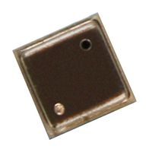

Figure 4.5.1: Renesas ZMOD4510AI1R

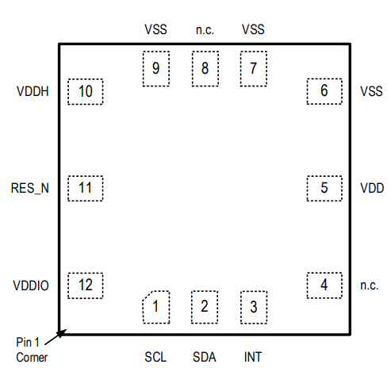

Figure 4.5.2: Pin Assignment of ZMOD4510AI1R

Table 1: Description of ZMOD4510AI1R

|  |  |  |
| --- | --- | --- |
| Sr No. | Property | Rating |
| 1. | Target operation temperature | -40°C to +65°C |
| 2. | Supply voltage | 1.7V to 3.6 V |
| 3. | I2C interface | up to 400 kHz |

2. SCD40-D-R1 Sensor:

The SCD4x is Sensirion’s next generation miniature CO2 sensor. CO2 is a key indicator for indoor air quality as high levels compromise humans’ cognitive performance and wellbeing. The SCD4x enables smart ventilation systems to regulate ventilation in the most energy-efficient and human-friendly way. Moreover, indoor air quality monitors and other connected devices based on the SCD4x can help maintaining low CO2 concentration for a healthy, productive environment.[7]

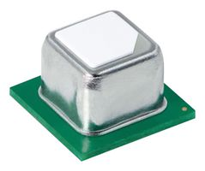

Figure 4.5.3: SCD40-D-R1 Sensor

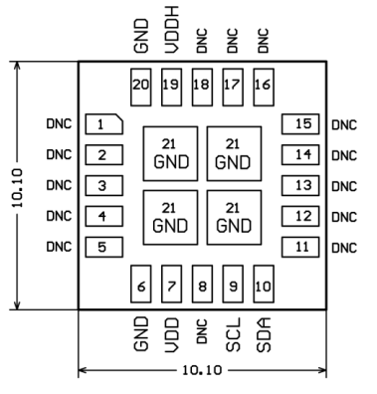

Figure 4.5.4: Pin assignment of SCD40-D-R1

Table 2: Description of SCD40-D-R1

|  |  |  |
| --- | --- | --- |
| Sr No: | Property | Rating |
| 1. | Supply voltage DC | 5.5 V |
| 2. | Operating Temperature | -10 – 60°C |
| 3. | Sensor lifetime | > 10 years |

3. MQ-136 Sensor:

MQ136 gas sensor has high sensitivity to H2S gas, also can monitor organic vapour including sulfur well. It a kind of low-cost sensor for kinds of applications.[8]

Features:

It has good sensitivity to H2S gas in wide range, and has advantages such as long lifespan, low cost and simple drive circuit &etc.

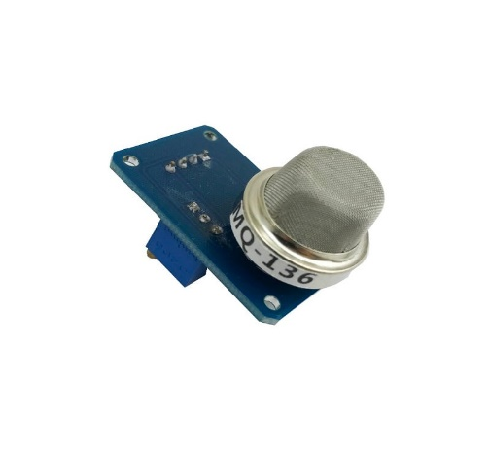

Figure 4.5.5: MQ136 Sensor

Table 3: Description of MQ136 Sensor

|  |  |  |
| --- | --- | --- |
| Sr No | Property | Rating |
| 1. | Sensor Type | Semiconductor |
| 2. | Target Gas | Hydrogen Sulfide(H2S gas) |
| 3. | Detection range | 1～200ppm |
| 4. | Input Voltage | 5.0V±0.1V |
| 5. | Temperature | 20℃±2℃ |
| 6. | Humidity | 55%±5%RH |

4. MS-1100 Sensor:

It is applied detection of VOCs gases like toluene, formaldehyde, benzene, etc. It is Semiconductor type sensor. [9]

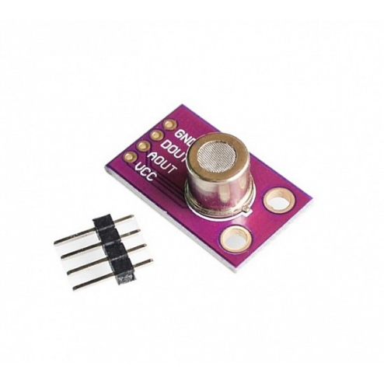

Figure 4.5.6: MS1100 Sensor

Table 4: Description of MS-1100 Sensor

|  |  |  |
| --- | --- | --- |
| Sr No | Property | Rating |
| 1. | Input Voltage | 5±0.1Volt |
| 2. | Operating Temperature | -10 ~ 50℃ |
| 3. | Power consumption | 380mW |
| 4. | Humidity | 5 ~ 90%RH |

5. CO Sensor Module ZE07-CO:

ZE07-CO is a general-purpose and miniaturization electrochemical carbon monoxide detection module. It utilizes electrochemical principle to detect CO in air which makes the module with high selectivity and stability. Built-in temperature sensor can do temperature compensation; and it has digital output and analog voltage output. It is a combination of mature electrochemical detection principle and sophisticated circuit design. [10]

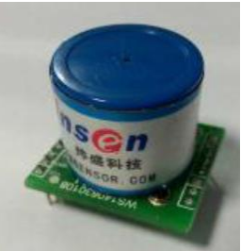

Figure 4.5.7: CO Sensor Module ZE07-CO

Table 5: Description of CO Sensor Module ZE07-CO

|  |  |  |
| --- | --- | --- |
| Sr No | Property | Rating |
| 1. | Working Voltage | 5V~12V |
| 2. | Detection Range | 0~500ppm |
| 3. | Operating Temp. | -10°C~55°C |
| 4. | Working life | 3-5 years (in air) |
| 5. | Operating Hum. | 15%RH~90%RH |

6. Raspberry Pi:

The Raspberry Pi is a low cost, credit-card sized computer that plugs into a computer monitor or TV, and uses a standard keyboard and mouse. It is a capable little device that enables people of all ages to explore computing, and to learn how to program in languages like Scratch and Python. [11]

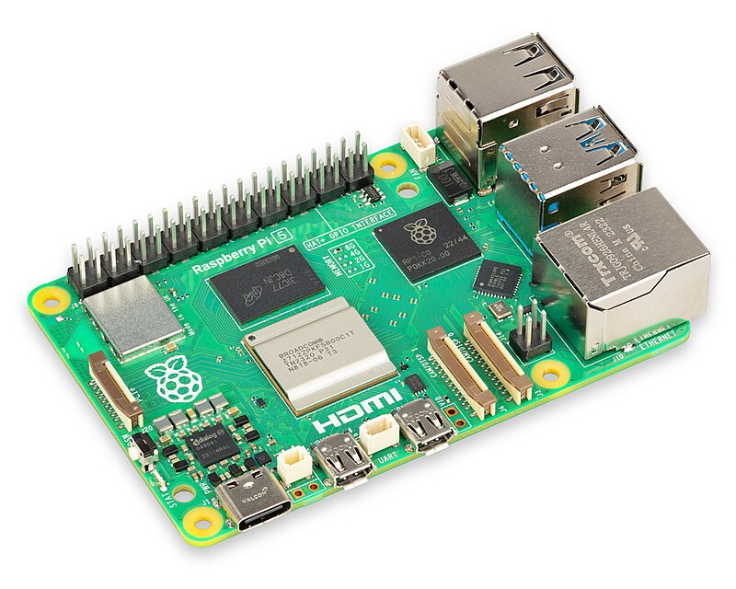

Figure 4.5.8: Raspberry Pi

7. Arduino:

Arduino is an open-source electronics platform based on easy-to-use hardware and software. Arduino boards are able to read inputs - light on a sensor, a finger on a button,- and turn it into an output - activating a motor, turning on an LED, publishing something online. [12]

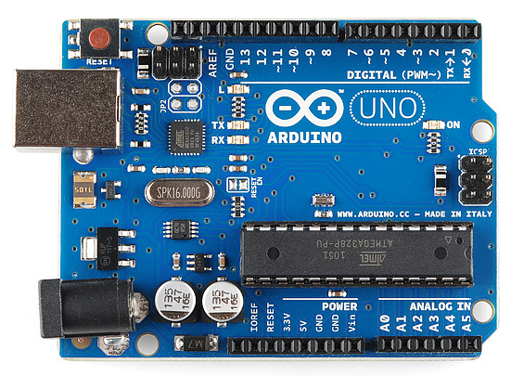

Figure 4.5.9: Arduino Board

**CHAPTER 5**

**EXPERIMENTATION**

1. **EXPERIMENTATION**

**5.1 INTRODUCTION**

In the pursuit of developing reliable gas detection systems, the experimentation phase plays a pivotal role in validating sensor performance under varying conditions. So in this part we focused on testing of two specific sensors, namely MQ136 and MS1100, to assess their responses to different concentrations of benzene, toluene, and formaldehyde. The concentrations selected for experimentation range from 1ml to 9ml for each gas, with increments at 1ml, 3ml, 6ml, and 9ml, offering a nuanced exploration of sensor capabilities across a spectrum of gas levels. To ensure statistical robustness and accuracy, each concentration level undergoes 20 cycles of testing for rigorous data collection.

The MQ136 sensor, known for its sensitivity to benzene and other volatile organic compounds (VOCs), is subjected to controlled concentrations of benzene to evaluate its responsiveness and precision. Simultaneously, the MS1100 sensor, designed for the detection of formaldehyde and other harmful gases, undergoes testing with varying concentrations of formaldehyde. The inclusion of toluene in the experiment further broadens the assessment, providing insights into the sensors' selectivity and reliability across different gas types.

This experimentation aims to generate a comprehensive dataset detailing the sensors' responses at different concentration levels, contributing valuable information to optimize their performance and accuracy. The multi-level approach, encompassing incremental concentrations and repeated cycles, ensures a thorough examination of sensor behavior under diverse scenarios. The outcomes of this experimentation are expected to inform the development and calibration of gas detection systems, fostering advancements in environmental safety and industrial applications where accurate gas sensing is imperative.

**5.2 TESTING OF SENSORS**

The objective is to comprehensively assess how sensors respond when subjected to varying gas concentrations. To simulate real-world scenarios, different gases—each with distinct characteristics—were injected into an enclosed tin using a syringe, mimicking a confined environment for systematic testing.

The experimental setup involves injecting precise concentrations of gases, including benzene, toluene, and formaldehyde, into the enclosed tin. The concentrations, carefully measured at 1ml, 3ml, 6ml, and 9ml, offer a spectrum of exposure levels. This controlled injection method, facilitated by a syringe, allows for accurate manipulation of gas quantities to ensure repeatability and consistency in the testing process.

The enclosed tin serves as a controlled environment, enabling the systematic observation of sensor responses to different gas concentrations. This approach facilitates the collection of nuanced data, shedding light on how sensors detect and react to various levels of each gas. The experimental design incorporates precision and repeatability, crucial elements in generating reliable data for subsequent analysis.

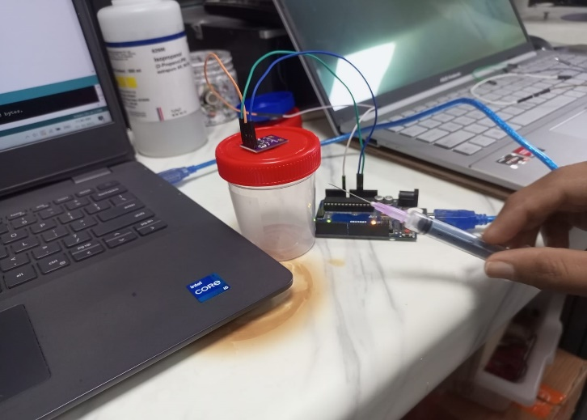 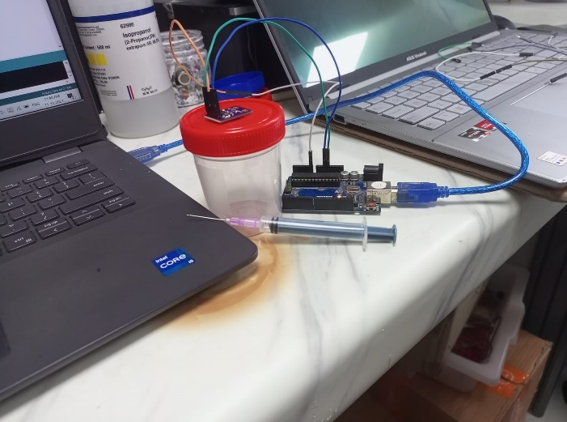

Figure 5.2: Testing of Sensors

**5.3 Final Model**

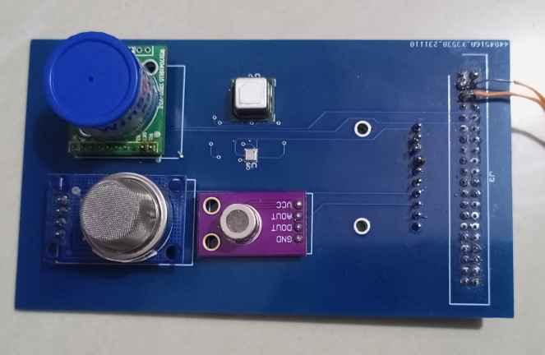

Figure 5.3.1: Initial PCB Desgin

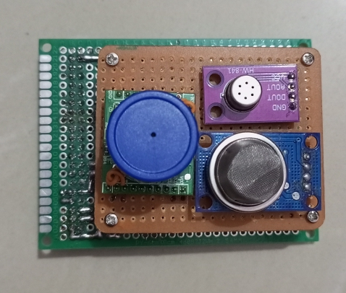

Figure 5.3.2: Proposed Model

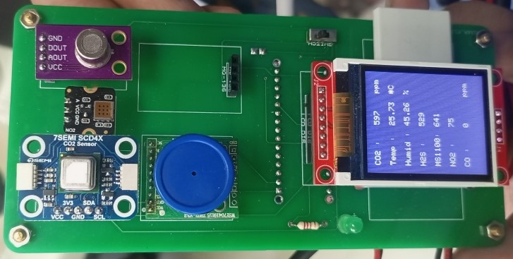

Figure 5.3.3: Front side of the model

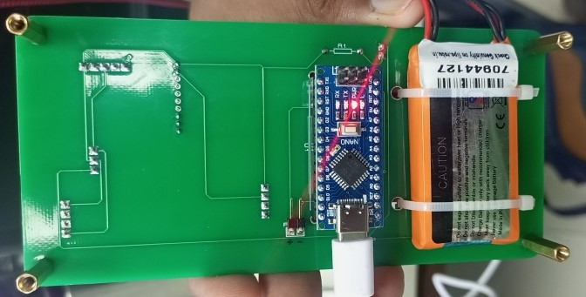

Figure 5.3.4: Backside of the model

**CHAPTER 6**

**RESULTS AND DISCUSSION**

1. **RESULTS AND DISCUSSION**

**6.1 INTRODUCTION**

The results obtained after completing the testing that involved injecting precise concentrations of benzene, toluene, and formaldehyde into the enclosed tin, the sensor responses were meticulously analyzed. The graphical representation of the data revealed distinct patterns and notable spikes corresponding to different gas concentrations. These spikes in the graph are indicative of the sensors' heightened reactivity and responsiveness to the injected gases.

For benzene, the graph exhibited discernible spikes in sensor output at each concentration level (1ml, 3ml, 6ml, and 9ml). These spikes, often characterized by elevated sensor readings, signify the sensor's acute sensitivity to increasing concentrations of benzene. The trend was consistent, demonstrating a proportional relationship between the injected benzene concentration and the sensor's response.

Similar patterns were observed for toluene and formaldehyde. The graph displayed conspicuous spikes corresponding to each concentration level, illustrating the sensors' ability to detect and react to varying concentrations of these gases. The spikes observed in the graph reflect the dynamic nature of sensor reactions, emphasizing their capacity to discern subtle changes in gas concentration.

These results are integral to understanding the sensors' performance across a spectrum of concentrations, providing valuable insights into their sensitivity and selectivity. The spikes in the graph serve as visual markers, highlighting the precise moments when the sensors register the presence of specific gases. This nuanced analysis contributes to the ongoing refinement of gas detection mechanisms, ensuring the reliability and accuracy of sensor responses in real-world applications.

**6.2 RESULTS**

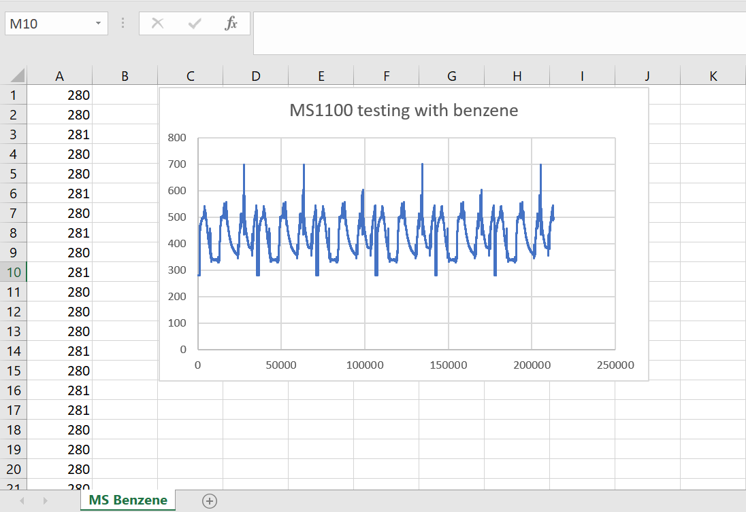

Figure 6.2.1: MS1100 Sensor reaction with Benzene

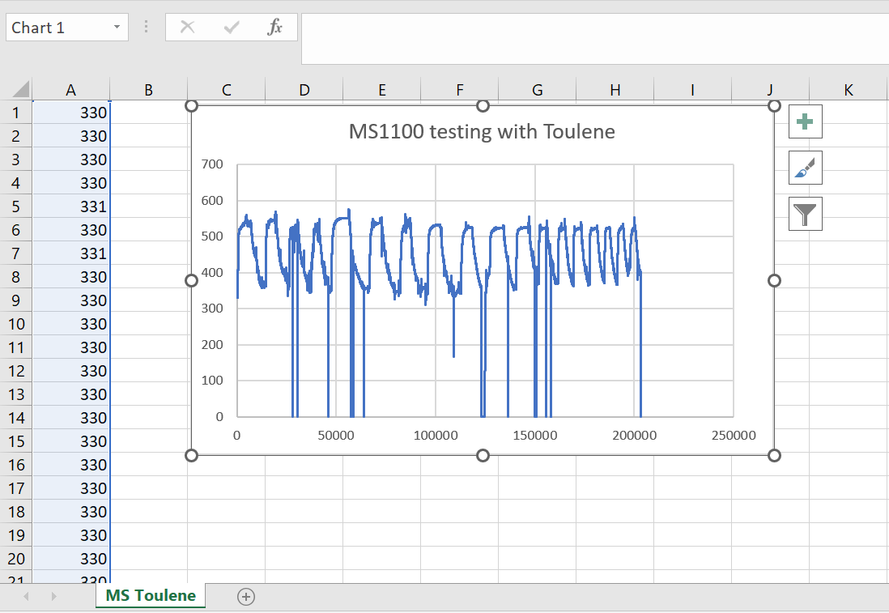

Figure 6.2.2: MS1100 Sensor reaction with Toluene

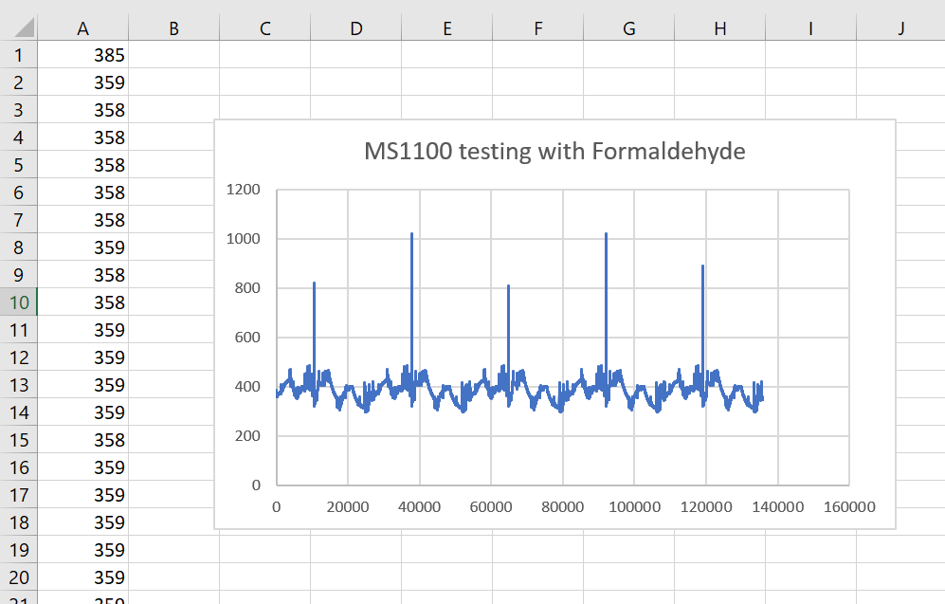

Figure 6.2.3: MS1100 Sensor reaction with Formaldehyde

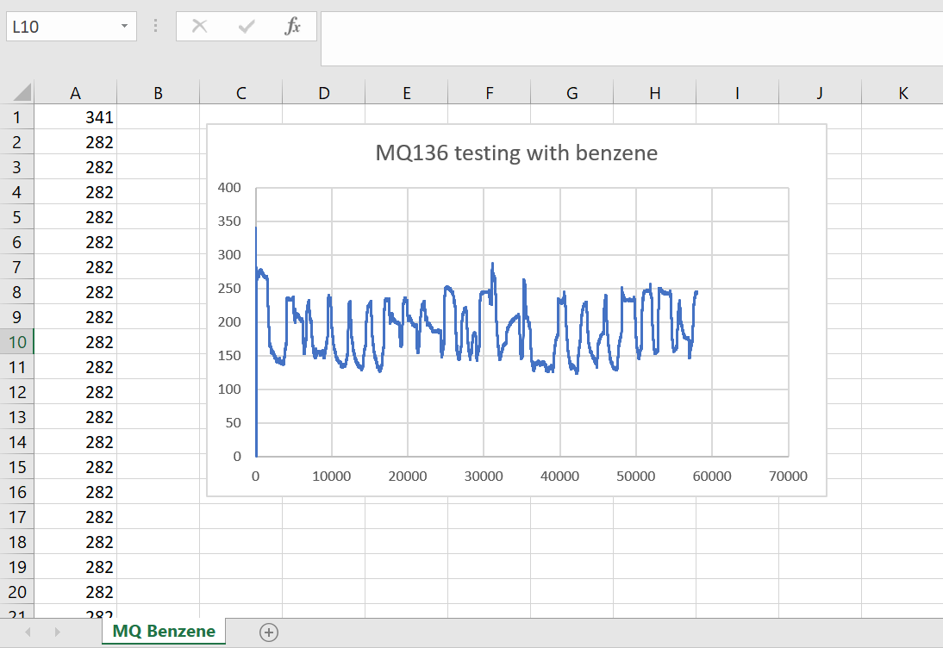

Figure 6.2.4: MQ136 Sensor Reaction with Benzene

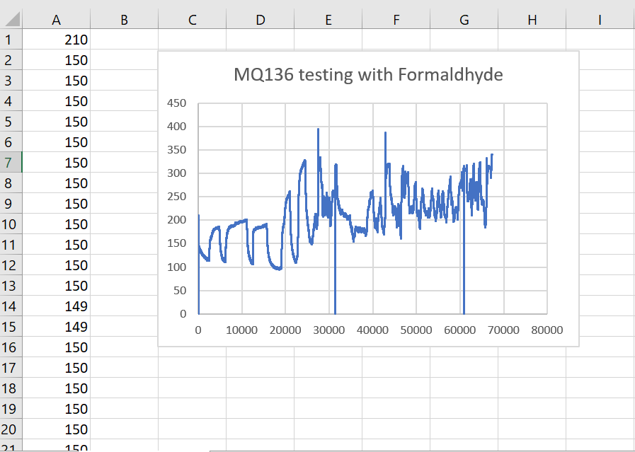

Figure 6.2.5: MQ136 Sensor Reaction with Formaldehyde

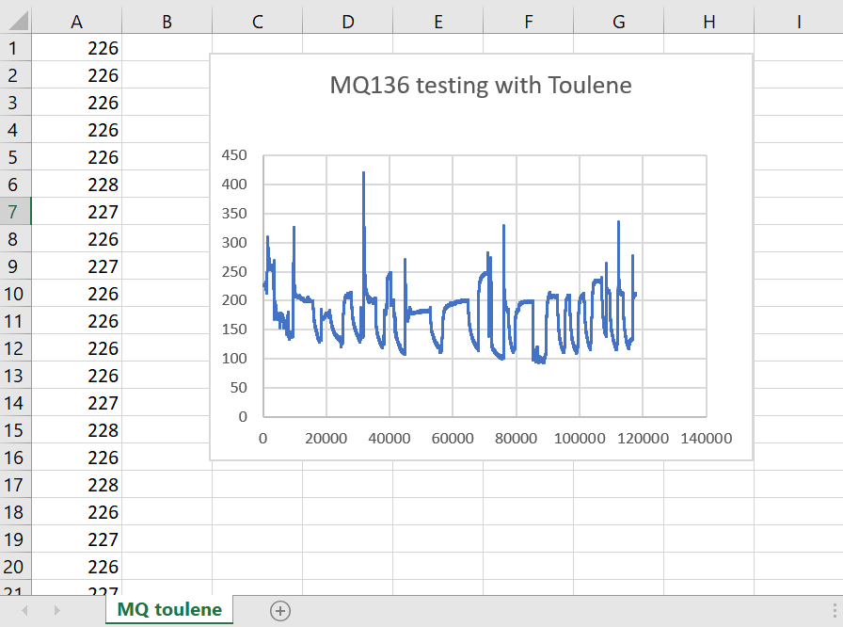

Figure 6.2.6: MQ136 Sensor Reaction with Toluene

**CHAPTER 7**

**CONCLUSIONS**

1. **CONCLUSIONS**

In conclusion, this proposed model stands as a pivotal advancement in ensuring human safety. The integration of diverse sensors, including ZMOD4510AI1R, SCD40-D-R1, MQ136, MS-1100, and CO Sensor Module ZE07-CO, lays the foundation for a comprehensive and versatile detection system. The utilization of both Raspberry Pi and Arduino for simultaneous data acquisition demonstrates the project's commitment to efficiency and real-time monitoring. This dual-platform integration ensures a robust and synchronized data collection process, enhancing the capabilities of the sensor array system. The sensor array system has been successfully employed for the detection of volatile organic compounds in a closed environment. The amalgamation of specialized sensors enables the system to identify a wide range of VOCs, contributing to environmental safety and well-being. The calibration of the sensor array for various concentrations of acetaldehyde, NO, and CO is a crucial accomplishment. This step ensures the accuracy and reliability of the sensors in detecting specific gases across different concentration levels. The calibrated system provides a foundation for precise and nuanced gas detection capabilities.

**CHAPTER 8**

**REFERENCES**

1. **REFERENCES**

[1] A. Holovatyy, V. Teslyuk, M. Lobur, S. Pobereyko and Y. Sokolovsky, "Development of Arduino-Based Embedded System for Detection of Toxic Gases in Air," 2018 IEEE 13th International Scientific and Technical Conference on Computer Sciences and Information Technologies (CSIT), Lviv, Ukraine, 2018, pp. 139-142, doi: 10.1109/STC-CSIT.2018.8526672.

[2] M. Jualayba, K. Regio, H. Quiozon And A. Destreza, "Hazardous Gas Detection and Notification System," 2018 IEEE 10th International Conference on Humanoid, Nanotechnology, Information Technology,Communication and Control, Environment and Management (HNICEM), Baguio City, Philippines, 2018, pp. 1-4, doi: 10.1109/HNICEM.2018.8666358.

[3] G. A. García-Rodriguez et al., "Detection of volatile organic compounds using a commercial gas sensor embedded in a mobile robot," 2020 IEEE International Conference on Engineering Veracruz (ICEV), Boca del Rio, Mexico, 2020, pp. 1-4, doi: 10.1109/ICEV50249.2020.9289677.

[4] “Very volatile organic compounds: an understudied class of indoor air pollutants” by T. Salthammer

[5] Epping, Ruben, and Matthias Koch. 2023. "On-Site Detection of Volatile Organic Compounds (VOCs)" Molecules 28, no. 4: 1598.

[6] A.K. Srivastava, Detection of volatile organic compounds (VOCs) using SnO2 gas-sensor array and artificial neural network, Sensors and Actuators B: Chemical, Volume 96, Issues 1–2, 2003, Pages 24-37,

ISSN 0925-4005.

[7] Galstyan, Vardan, D’Arco, Annalisa, Di Fabrizio, Marta, Poli, Nicola, Lupi, Stefano and Comini, Elisabetta. "Detection of volatile organic compounds: From chemical gas sensors to terahertz spectroscopy" *Reviews in Analytical Chemistry*, vol. 40, no. 1, 2021, pp. 33-57.

[8] Itoh, T.; Koyama, Y.; Shin, W.; Akamatsu, T.; Tsuruta, A.; Masuda, Y.; Uchiyama, K. Selective Detection of Target Volatile Organic Compounds in Contaminated Air Using Sensor Array with Machine Learning: Aging Notes and Mold Smells in Simulated Automobile Interior Contaminant Gases. Sensors 2020, 20, 2687

[9] Datasheet of ZMOD4510AI1R <https://4donline.ihs.com/images/VipMasterIC/IC/RNCC/RNCC-S-A0011616774/RNCC-S-A0012988086-1.pdf?hkey=6D3A4C79FDBF58556ACFDE234799DDF0>

[10] Datasheet of SCD40-D-R1 <https://www.farnell.com/datasheets/3194661.pdf>

[11] Datasheet of MQ136 <http://www.datasheet.es/PDF/904646/MQ-136-pdf.html>

[12] Datasheet of MS-1100 <https://datasheetspdf.com/pdf-file/813045/ETC/MS1100/1>

[13] Datasheet of ZE07-CO

<https://www.winsensensor.com/d/files/PDF/Gas%20Sensor%20Module/CO%20Detection%20Module/ZE07%20CO%20Module%201.3V.pdf>

[14]RaspberryPi:<https://www.raspberrypi.com/documentation/#:~:text=The%20Raspberry%20Pi%20is%20a,languages%20like%20Scratch%20and%20Python>.

[15] Arduino:<https://www.arduino.cc/en/Guide/Introduction>